# Troubleshoot object synchronization with Azure AD Connect sync

This topic provides steps for how to troubleshoot issues with object synchronization using the troubleshooting task.

For Azure Active Directory (AAD) Connect deployment with version <verison> or higher, use the troubleshooting task in the wizard to troubleshoot object synchronization issues. For earlier versions, please troubleshoot manually as described [here](https://docs.microsoft.com/en-us/azure/active-directory/connect/active-directory-aadconnectsync-troubleshoot-object-not-syncing).

## Run the troubleshooting task in the wizard

To run the troubleshooting task in the wizard, perform the following steps:

1. Open a new Windows PowerShell session on your Azure AD Connect server with the **Run as Administrator** option.
2. Run Set-ExecutionPolicy RemoteSigned or Set-ExecutionPolicy Unrestricted.
3. Start the Azure AD Connect wizard.
4. Navigate to the **Additional Tasks** page, select **Troubleshoot**, and click **Next**.
5. On the Troubleshooting page, click **Launch** to start the troubleshooting menu in PowerShell.
6. In the main menu, select **Troubleshoot Object Synchronization**.

## Troubleshooting Input Parameters

The following input parameters are needed by the troubleshooting task:

1. Object Distinguished Name – This is the distinguished name of the object that needs troubleshooting
2. AD Connector Name – This is the name of the AD forest where the above object resides.
3. Azure AD tenant global administrator credentials

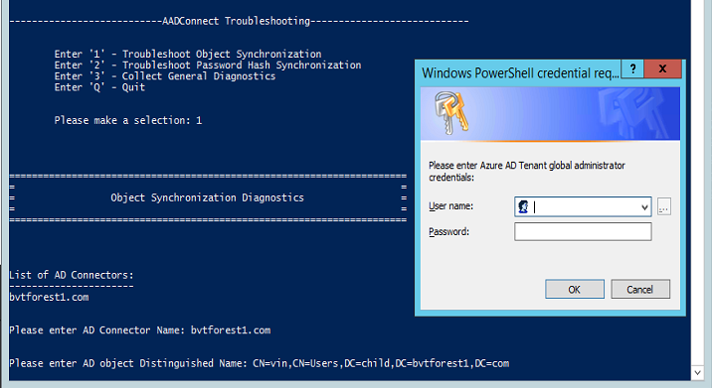

## Understand the results of the troubleshooting task

The troubleshooting task performs the following checks:

1. Detect UPN mismatch in case the object is synced to Azure Active Dire0ctory
2. Check if object is filtered due to domain filtering
3. Check if object is filtered due to OU filtering

The rest of this section describes specific results that are returned by the task. In each case, the task provides an analysis followed by recommended actions to resolve the issue.

### Detect UPN mismatch in case object is synced to Azure Active Directory

#### UPN Suffix is NOT verified with Azure AD Tenant

When UserPrincipalName (UPN)/Alternate Login ID suffix is not verified with Azure AD Tenant, then Azure Active Directory replaces such UPN suffixes with default domain name "onmicrosoft.com".

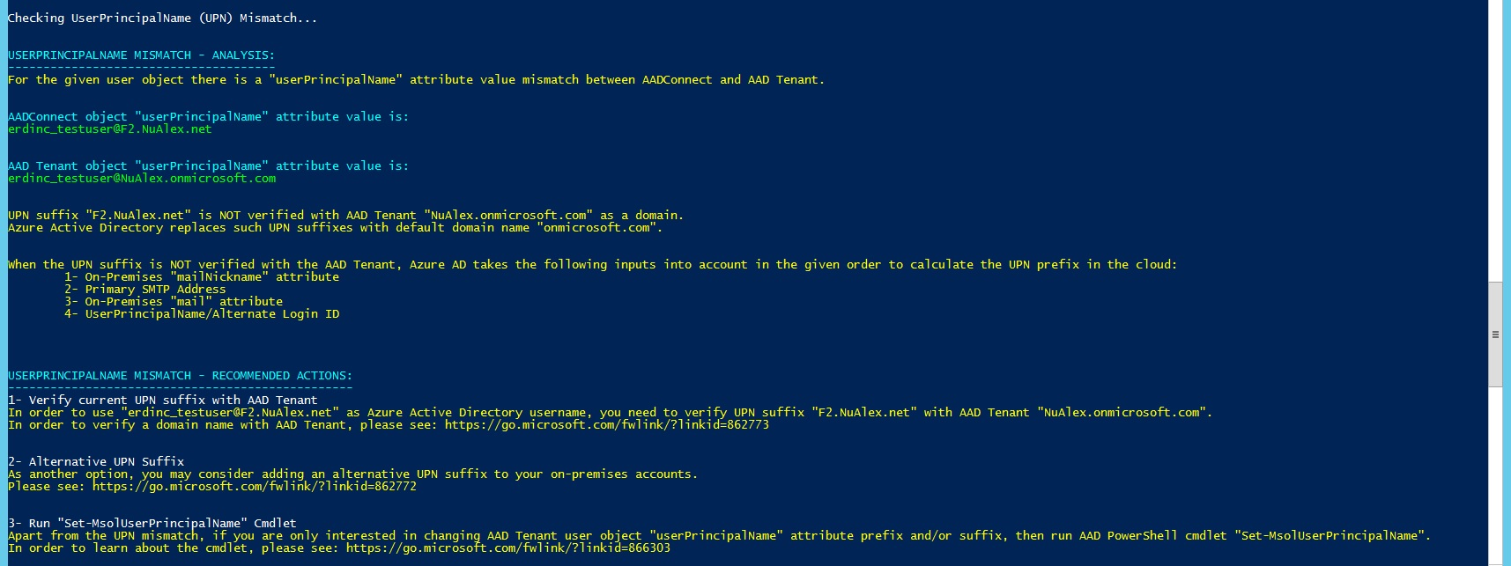

#### Changing UPN Suffix from one federated domain to another federated domain

Azure Active Directory does not allow to synchronize UserPrincipalName (UPN)/Alternate Login ID suffix change from one federated domain to another federated domain. This applies to domains which are verified with Azure AD Tenant and having Authentication Type as Federated.

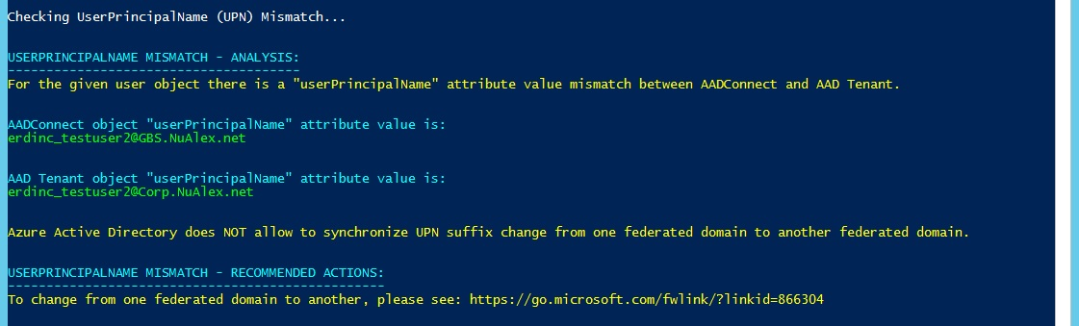

#### Azure AD Tenant DirSync Feature ‘SynchronizeUpnForManagedUsers’ is disabled

When Azure AD Tenant DirSync Feature ‘SynchronizeUpnForManagedUsers’ is disabled, Azure Active Directory does not allow to synchronize updates to UserPrincipalName/Alternate Login ID for licensed user accounts with managed authentication.

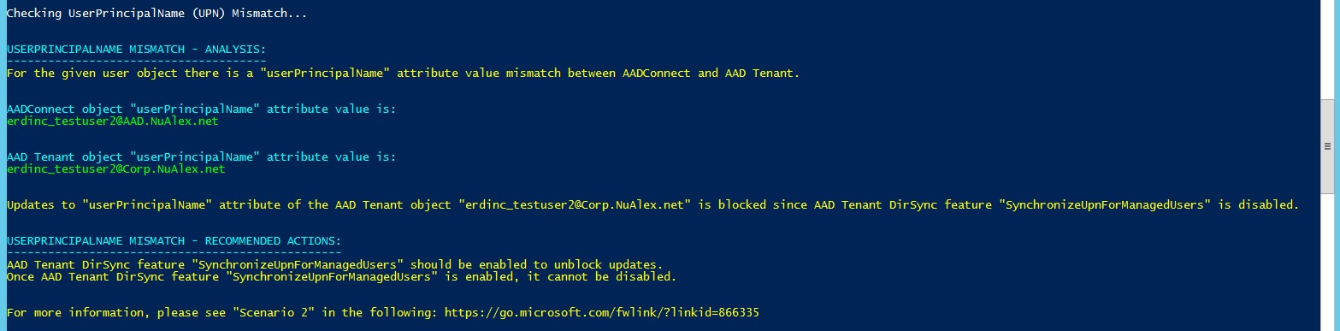

### Object is filtered due to domain filtering

#### Domain is not configured to sync

Object is out of scope due to domain not being configured. In the example below, the object is out of sync scope as the domain that it belongs to is filtered from synchronization.

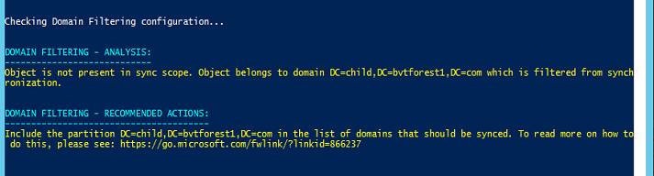

#### Domain is configured to sync but is missing run profiles/run steps

Object is out of scope as the domain is missing run profiles/run steps. In the example below, the object is out of sync scope as the domain that it belongs to is missing run steps for the **Full Import** run profile.

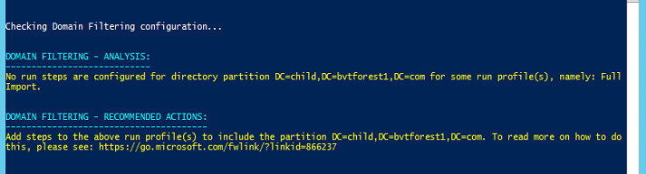

### Object is filtered due to OU filtering

Object is out of sync scope due to OU filtering configuration. In the example below, the object belongs to **OU=NoSync,DC=bvtadwbackdc,DC=com** which is not included in sync scope.

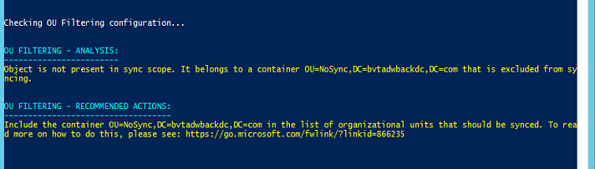

## HTML Report

In addition to analyzing the object, the troubleshooting task also generates a HTML report that has everything we know about the object. This HTML report can be shared with support team to do further troubleshooting, if needed.

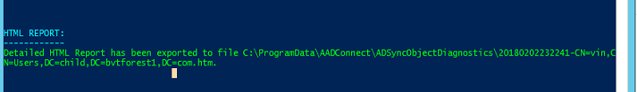

## Upcoming Features

1. Localization support
2. Support multiple azure instances
3. Other enhancements